Home-Brew Innovators Prove Simple, Plant-Based Remedies Could Revolutionize Skincare

October 6, 2014

by [Hannah Ritchie](http://www.sustainablebrands.com/user/138368)

1  
[in**Share**](javascript:void(0);)

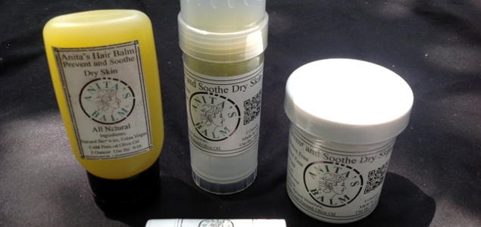

Image credit: [Anita's Balm](http://www.anitasbalm.com/Store.html)

For most people with skin problems, the solution is to try every possible remedy and product out there until they find one that works. But when the alternatives don’t work, some enterprising patients decide to make their own.

Anita Redd took matters into her own hands when conventional remedies were no match for her infant son’s eczema — a painful condition causing inflamed and itchy skin. From birth, Kevin suffered from flaky and blistered patches on his body. When doctors recommended putting him on creams and steroids with potential side effects such as stunted growth, infections and hypertension, Redd decided to look elsewhere for alternatives.

Anita's Balm's new biodegradable packaging

“It's unfathomable to have to live with the side effects for decades," Redd said in a statement. "Perhaps it's different when you get it as an adult, but he would have to live with those for all of those years. That was just unacceptable."

When a wide range of treatments — including prescription medicines and natural remedies — proved ineffective, she decided to try out a solution of her own. She knew that olive oil managed to bring some relief, so she combined it with beeswax to give it the texture of a solidified cream. This was the birth of [Anita’s Balm](http://www.anitasbalm.com/) — what has become a life-changing moisturizer for many suffering from chronic skin conditions, including eczema and psoriasis.

After sharing the remedy with only friends and family for a while, Redd brought the product to market in 2011. Anita’s Balm gained scope rapidly — it is now stocked in more than 1,300 stores nationwide and has been attracted network news attention everywhere from Macon, Georgia, to Columbus, Ohio, to Albany, Charleston and Atlanta.

Faced recently with the dilemma of rapidly rising sales alongside the discontinuation of her product’s bottles, Redd created another unique solution: 3D-printed, biodegradable packing.

"I have no chemical background, but I was going to figure it out," Redd said.

Designing her own containers not only gives Redd control over her packaging, it also adds an additional sustainable benefit to her product — avoiding the [variety of environmental issues](http://www.sustainablebrands.com/news_and_views/packaging/jennifer_elks/valuing_plastic_illustrates_critical_need_companies_disclose_) that persistent plastics from packaging create.

"It's the only one like it on the planet," Redd said of the patent-pending design. "The ability to compost and biodegrade is really going to impact the cosmetics industry in unimaginable ways."

Her commitment to finding new solutions has reaped its benefits: The first batch of her new 1-oz biodegradable roll-up containers sold out within weeks.

